**GENERAL INFORMATION**

APP NAME: Vancouver TransLink Live

VERSION: 1.2.20

DEVELOPER: Jamie O’Toole

LAST UPDATED: January 15, 2017

DOWNLOADS: 1,000 - 5000

PLAY STORE RATING: 4.2

**Introductory Paragraph**

Vancouver TransLink Live is a location based transit guide for the Metro Vancouver area. It displays nearby stops, allows users receive a trip plan to popular destination, receive schedule for selected bus stops to name a few of the main features. It allows for users to quickly navigate to the next bus coming to nearby/favourite stops and find the best route to reach their destination.

**Usability (35)**

The app is simple to use and navigate it contains a simplistic interface that allows users to quickly find the information on bus schedules and routes with relative ease and speed.

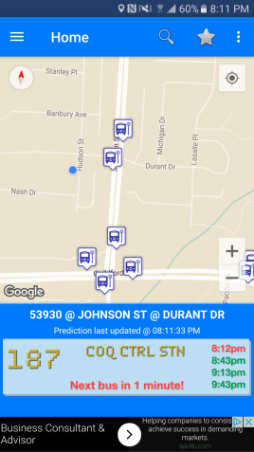

The app requires that gps be on to make full use of the features when gps is turned the app opens to a map of the local area with nearby bus stops and station marked. This feature allows users to quickly check the schedule of the stops without having to search by Id or name. But if you want to look at a stop that is out of you current range you will have to search for it since the app only displays nearby stops and stops flagged as favourites when it first opens.

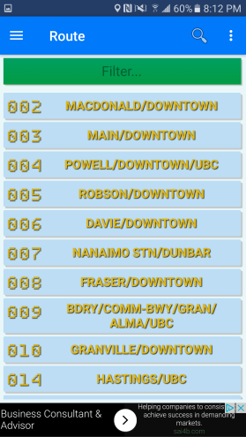When searching the app allows users to search for either route or stop when a route is selected all stops along that route are marked on the map allowing users to find the nearest stop to their location. When stop is selected the app displays the arrival time of the next few buses/trains for all the buses/trains that use the selected stop.

The app does not allow for future planning since it is limited to only buses and trains coming in the next little while it do not allow users to future plan. The app also creates confusion when selecting a stop after selecting a particular route as it then takes you to from displaying the routes to displaying the stop which if you are looking at a specialty bus that has no upcoming times if you don’t look carefully it could be easy to mistake one bus for another.

The app also struggles with the sky trains routes as it will incorporate them into trip plans and display the routes/stations when searched for but when clicked on bring the user to a page that does not give any of the upcoming times of the trains.

**Responsiveness (20)**

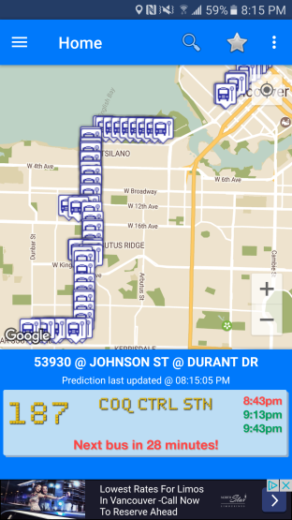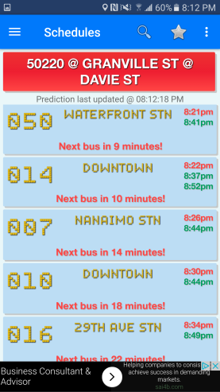 Overall the app has a quick response time there is no noticeable load time even when finding and displaying your current location. The search function overall is quite fast with the only delay being broad searches such as searching for stops with the letter “A”. When calculating trip plan the app has almost no delay and loads the plan almost immediately overall the speed of the app is excellent.

**Aesthetics (20)**

The app is simplistic and map based it contains gentle colour tones that make it easy on the eyes the functions are laid out in an orderly fashion. Making them easy to find and adding to the overall style of the app. The app makes use of the old saying “less is more” as the developer kept the screen as simple as possible only initially displaying what is needed. This is especially noticed with the stops as the app only displays the nearby stops on start up it keeps the screen from becoming cluttered and overwhelming when it is first opened.

**Support (15)**

The app receives good support from the developer as of now even though it is a relatively small transit app. Looking through the comments and some complaints of the app of the play store when a complaint was made the developer would often address the complaint inquiring what wasn’t working or the user did not like so that he may further improve upon his app.

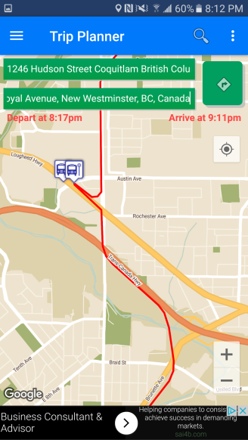

**Additional Features (10)**

Besides the traditional expect functions of a transit app such as trip planner, display of schedules and local routes that developer add a few interesting features to the app. One such feature is bus prediction this feature automatically runs on start up this features tells the user via banner at the bottom of the screen when the next bus for the nearest favourite stop is coming. If no favourite’s stops are within range the app automatically selects the nearest stop and displays the next bus for that stop. Then the prediction will update whenever the user selects another stop making it easy for the user to check when the next bus is coming by. The app will also mark and unmark stops on the map based on user selection for instance when selecting a route is will display all stops along that route but once the route is deselected the map will hide all of the routes again keeping the map nice and clean.

**Final Conclusions**

The app for the most part does what is expected of it quite well it plans trips accurately and displays the routes and schedule in a neat and easy to read fashion. But I feel the app could be improved upon in the skytrain section as the info isn’t always displayed. Furthermore the even though you can look at the info offline the app is map designed so it loses most of its functionality when offline. In conclusion the app does do what is said it would do but leaves room for improvements.

|  |  |  |
| --- | --- | --- |
| Criteria | Weight | Score |
| Usability: | 35 | 28 |
| Responsiveness: | 20 | 15 |
| Aesthetics: | 20 | 18 |
| Support: | 15 | 13 |
| Additional Features: | 10 | 9 |
| Total: | 100 | 83 |